A 3PL, or Third-Party Logistics, company is a business that provides outsourced logistics and supply chain management services to other companies. These companies specialize in handling various aspects of the logistics process, allowing their clients to focus on their core business activities. The term "3PL" refers to the three parties involved in the logistics process: the client (the company that needs logistics services), the shipper (the company that physically moves the goods), and the 3PL provider (the outsourced logistics service provider).
Services offered by 3PL companies can include transportation, warehousing, order fulfillment, distribution, freight forwarding, and other value-added services such as packaging, labeling, and returns management. By outsourcing these logistics functions to a 3PL provider, businesses can often benefit from cost savings, improved efficiency, and access to specialized expertise.
3PL companies play a crucial role in helping businesses manage their supply chains more effectively, especially in complex and global logistics environments. They can handle the complexities of transportation, inventory management, and distribution, allowing their clients to focus on their core competencies.

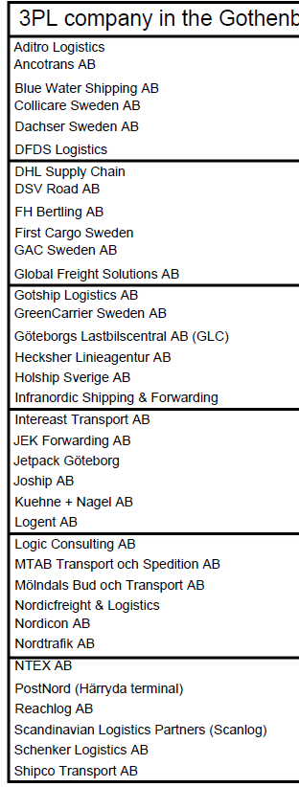

General Information:
- Can you provide an overview of Plejd's operations and the industry you operate in?
- How critical is efficient logistics and supply chain management for Plejd's overall business success?

Current Logistics Setup:
- Can you describe Plejd's current logistics structure and operations?
- What logistics challenges or pain points has Plejd experienced in the past?

Engagement with 3PL:
- What factors led Plejd to engage with a third-party logistics provider?
- How long has Plejd been working with the current 3PL company?

Services and Expectations:
- What specific logistics services does Plejd currently receive from the 3PL provider?
- Are there any specific expectations or requirements Plejd has from the 3PL in terms of service levels?

Key Performance Indicators (KPIs):
- How does Plejd measure the performance of the 3PL provider? Are there specific KPIs that are particularly crucial?
- Can you provide examples of instances where the 3PL exceeded expectations or faced challenges?

Technology and Innovation:
- How important is technology in Plejd's logistics operations?
- Is Plejd leveraging any specific technologies or innovations to enhance its logistics processes?

Flexibility and Scalability:
- How well does the 3PL provider adapt to changes in Plejd's demand or business requirements?
- In terms of growth, how scalable is the current logistics arrangement?

Collaboration and Communication:
- How is the communication and collaboration between Plejd and the 3PL company managed?
- Have there been instances where effective communication played a crucial role in addressing challenges?

Value-Added Services:
- Are there any additional value-added services that Plejd receives from the 3PL provider?
- How do these value-added services contribute to Plejd's overall business objectives?

Future Perspectives:
- As Plejd looks to the future, how do you envision the role of logistics evolving for the company?
- Are there any specific expectations or changes Plejd anticipates in its logistics strategy?

These questions should provide a solid foundation for gaining insights into Plejd's experiences with their 3PL provider and help you understand the customer's perspective.

